**Linear Regression:**

The Linear Regression is used for solving Regression problems.

* Linear Regression is one of the most simple Machine learning algorithm that comes under Supervised Learning technique and used for solving regression problems.
* It is used for predicting the continuous dependent variable with the help of independent variables.

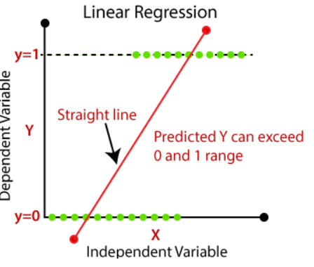

The regression line can be written as:

y= a0+a1x+ ε

Where, a0 and a1 are the coefficients and ε is the error term.

**Logistic Regression:**

* Logistic regression is one of the most popular Machine learning algorithms that come under Supervised Learning techniques.
* It can be used for Classification as well as for Regression problems, but mainly used for Classification problems.

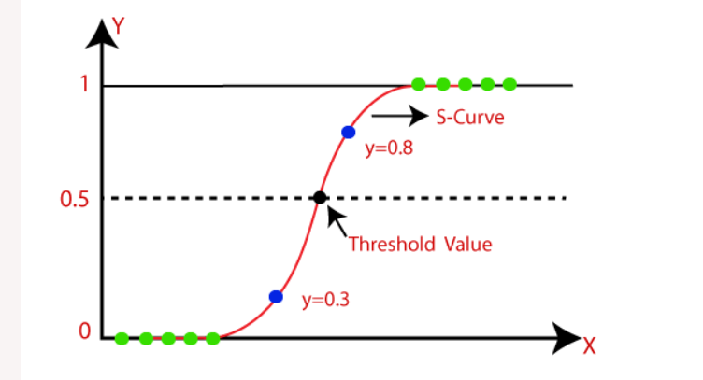

**Logistic Regression :**

inear Regression vs Logistic Regression